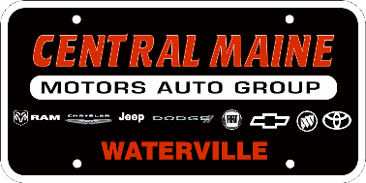
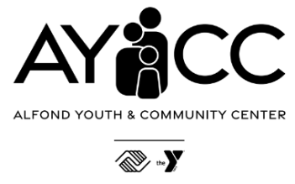
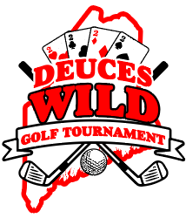

2026 Deuce’s Wild Golf Tournament
Sponsor Information
Introducing Central Maine Motors Auto Group Deuce’s Wild Golf Tournament, a 2-person scramble fundraising golf tournament for the Alfond Youth & Community Center. This uniquely entertaining & competitive tournament, on one of Maine’s top golf courses, has been specifically designed to maximize fun, competition, comradery, risk & reward, all to support children and families throughout Central Maine. Featuring four $10,000 hole in one prizes on all par 3’s, “Drive for e$25k” par 4 hole in one, bonus challenges throughout the course, and even a back off challenge hole – the only losers will be those that don’t get their team entered in the limited 108 player field.
Location : Waterville Country Club
Date & Time: Wednesday, August 19th 10am shotgun start (9am breakfast & registration)
Format: 2 Person Scramble, 3 teams per hole
Entry Fee: $350/team

Sponsorship Levels
Your support helps us maximize impact while offering meaningful visibility for your business before, during, and after the event. Year one sponsorship levels have been reduced to maximize sponsor engagement and create a high energy event.
Sponsorship Level | Investment | Recognition & Benefits
Presenting – Central Maine Motors Auto Group | $10,000 | - Exclusive naming recognition as Title Sponsor  - Premium logo placement on all event marketing (print/digital), registration materials, and signage.  - On-course visibility: prominent signage at registration, putting/contest area, & clubhouse.  - Speaking opportunity at awards/announcements  - Tabling on course available  - Social media & email spotlight leading up to the tournament and post-event thank you feature.  - Included teams: up to 2 Teams (4 players).  - Drive FORE $25k Hole-In-One  - 1st rights of refusal in 2027
Eagle  Breakfast  Lunch  Golf Towel  Golf Balls | $5,000 $2,500 | - Large logo on event materials and sponsor board.  - Prominent signage at a featured area  - Dedicated social media thank-you post.  - Included teams: 1 Team (2 players)
Birdie  Hole In Ones  Carts  Tees  Tote Bag  Putting Contest  Driving Range | $2,500  $1,250 | - Logo on event materials and sponsor board.  - Signage at one on-course location (tee box or activity area).  - Group social media thank-you recognition.  - Included teams: 1 Team (2 players) or equivalent entries.
Par  Activated Holes | $1,000  $500 | - Name/logo on sponsor board and event-day signage.  - One tee sign on course at hole with featured activation.  - Group social media thank-you recognition.
Hole  Standard Holes | $500  $250 | - Name/logo on sponsor board and event-day signage.  - Recognition on sponsor board.  - Group social media thank-you recognition.

Featured Hole Activations
Stand out from the crowd by attaching your brand to one of our featured prizes or activation holes.
Front 9
1 | Straightest Drive
2 | Hole In One - $10,000 – CO Beck & Sons
3
4 | “Drive” Fore $25K - CMMAG
5
6 | Hole In One - $10,000
7 | Boat Hole – Chip-In Challenge
8
9 | Warp Portal Hole – Land in portal, advance ball
Back 9
10
11
12 | Back Off Challenge – Capital City Improve
13 | Hole in One - $10,000
14
15
16 | Hole in One - $10,000
17
18 | Long Drive
P | Putting Green – Putting Contest
D | Driving Range – Free Range Balls

Team Prizes & Individual Awards
Top 3 teams Gross & Net
Longest Drive
Straightest Drive
Closest to Pin (all par 3’s)
Boat Chip-In Challenge
Putting Contest

Sponsorship Agreement / Contact Information
Sponsor: Contact name
Address
Phone __________ E-mail ____________
☐ Payment is enclosed. Checks payable to Alfond Youth & Community Center. Contributions are tax-deductible. TAX ID #
☐ VISA, MC, AM EX, Discover #
Exp. date V-code
Name on credit card Signature
☐ Please send an invoice.
☐ In-kind Service (w/approval). List Terms:
Sponsor Representative Signature: Date:

Questions of FMI contact Patrick Guerette, pguerette@clubaycc.org

Team Registration Link & QR Code:
https://tourneymachine.com/Public/Results/Tournament.aspx?IDTournament=h20260616200620936bc152fd878d04f
